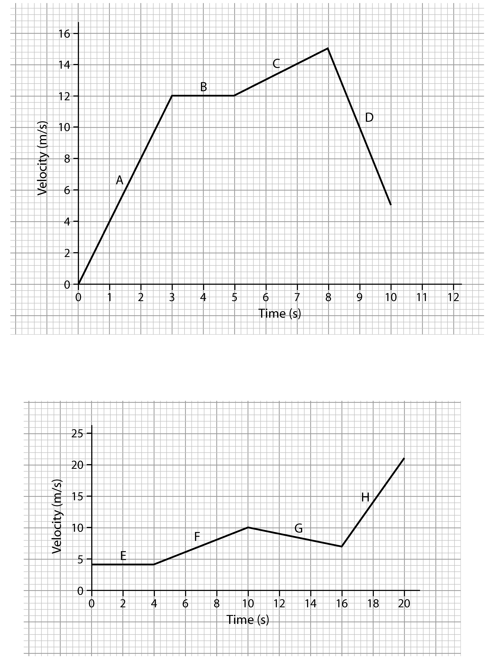

Gradient = **acceleration (m/s2)**

A = accelerating

B = constant speed

C = accelerating (slower than A)

D = decelerating

**Gradient = y / x**

Spot the difference!

If in doubt, check the units.

Time (s)

*v-u*

a t

d

s t

Final velocity = *v*

Initial velocity = *u*

Change in velocity = *v - u*

Gradient = **speed (m/s)**

A = constant speed

B = stationary

C = constant speed (lower than A)

D = constant speed (coming back)

Distance (m)

Time (s)

Velocity (m/s)

Key words Units Symbol

Time = how long an object has travelled for s t

Distance = how far an object has travelled m d

Speed = how fast an object is going m/s s

Velocity = how fast an object is going in a given direction m/s *v*

Acceleration = rate of change of velocity m/s2 a